Q1. Make a button with text “Show More” and underline it on hover.

Q2 Write “Lorem Ipsum is simply dummy text of the printing and typesetting industry”

and strike through it.

Q3 Use word-break properties inside a box with content so as to see the difference. Word

can be “spectrophotofluorometrically”

Q4 . Use ellipsis to hide the content in a box.

Ans.

Output: 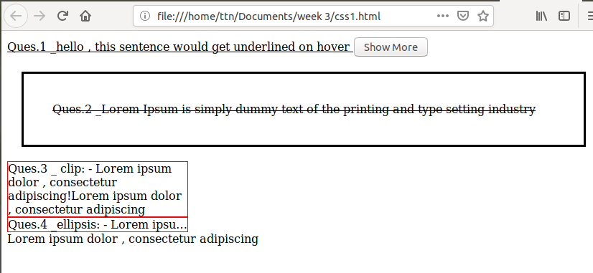

Code:

<!DOCTYPE html>

<html>

<head>

<title> text </title >

<style >

.div2{

border: solid black;

margin:20px;

text-decoration:line-through;

padding: 40px;

}

#div31{

border:1px solid red;

width: 250px;

text-overflow: clip;

}

#div32{

white-space: nowrap;

overflow:hidden;

border:1px solid red;

width: 250px;

text-overflow: ellipsis;

}

</style>

</head>

<body>

<div id="hey"> Ques.1 _hello , this sentence would get underlined on hover

<button id="btn"> Show More </button>

</div>

<div class="div2">Ques.2 _Lorem Ipsum is simply dummy text of the printing and type setting industry</div>

<div class="div3">

<div id="div31">Ques.3 _ clip: - Lorem ipsum dolor , consectetur adipiscing!Lorem ipsum dolor , consectetur adipiscing

</div>

<div id="div32"> Ques.4 _ellipsis: - Lorem ipsum dolor , consectetur adipiscing!Lorem ipsum dolor , consectetur adipiscing

</div>

<div id="div33">Lorem ipsum dolor , consectetur adipiscing

</div>

</div>

<script src="http://ajax.googleapis.com/ajax/libs/jquery/2.1.3/jquery.min.js"></script>

<script>

$(document).ready(function(){

$('#btn').hover(function(){

$('#hey').css('text-decoration','underline')

})

});

</script>

</body>

</html>

……………..

Q5.On a page with heading and para tags , use em values font size.

Q6 .On a page with heading and para tags , use rem values font size.

Q7.Use indentation 50px on a paragraph.

Q8.Maintain a paragraph with text shadow #dedede also give the blur effect.

Ans.

Output: 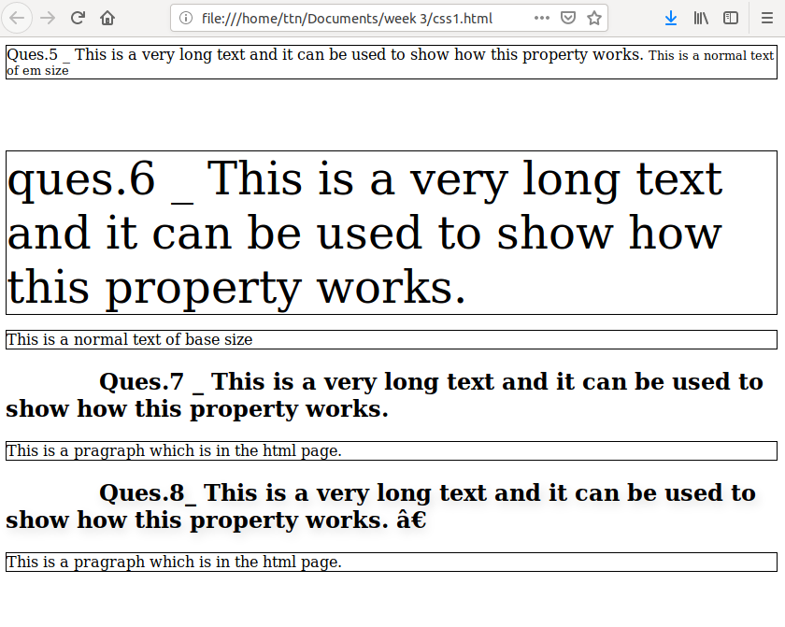

Code:

<html>

<head>

<style >

.ques5 {

font-size: 16px;

border: 1px solid black;

}

span{

font-size: 0.8em;

}

html {

font-size:16px;

}

.ques6 {

font-size: 3rem;

border: 1px solid black;

}

p{

border: 1px solid black;

}

h2{

text-indent: 100px;

}

.ques8 {

text-shadow: 3px 5px 10px #dedede;

}

</style>

</head>

<body>

<div class="ques5"> Ques.5 _ This is a very long text and it can be used to show how this property works.

<span> This is a normal text of em size</span> </div>

<br><br><br> <br>

<div class="ques6"> ques.6 _ This is a very long text and it can be used to show how this property works.

</div>

<p> This is a normal text of base size</p>

<h2> Ques.7 _ This is a very long text and it can be used to show how this property works.

</h2>

<p>This is a pragraph which is in the html page.</p>

<h2 class="ques8"> Ques.8_ This is a very long text and it can be used to show how this property works. ”

</h2>

<p>This is a pragraph which is in the html page.</p>

</body>

</html>